**Project Work Progress Report No 4**

Date: 03/31/2019 Team #: 33

Project Title: Intelligent Door System

Submitted by Gregory Escobar, Stephen Benavides, Shawn Carnevale, Geomar Reyes

1. Project progress since last report:

**Hardware**

The power system was tested in different scenarios. Results obtained showed that this system could power the microcontroller (ESP32), the solenoid and LEDs in case of a power outage for at least 10 hours due to the high capacity 18650 lithium cell. Solenoid was tested at different voltages in order to find the optimal input that would consume as low power as possible. GPIOs and power pins were finalized to proceed to PCB design.

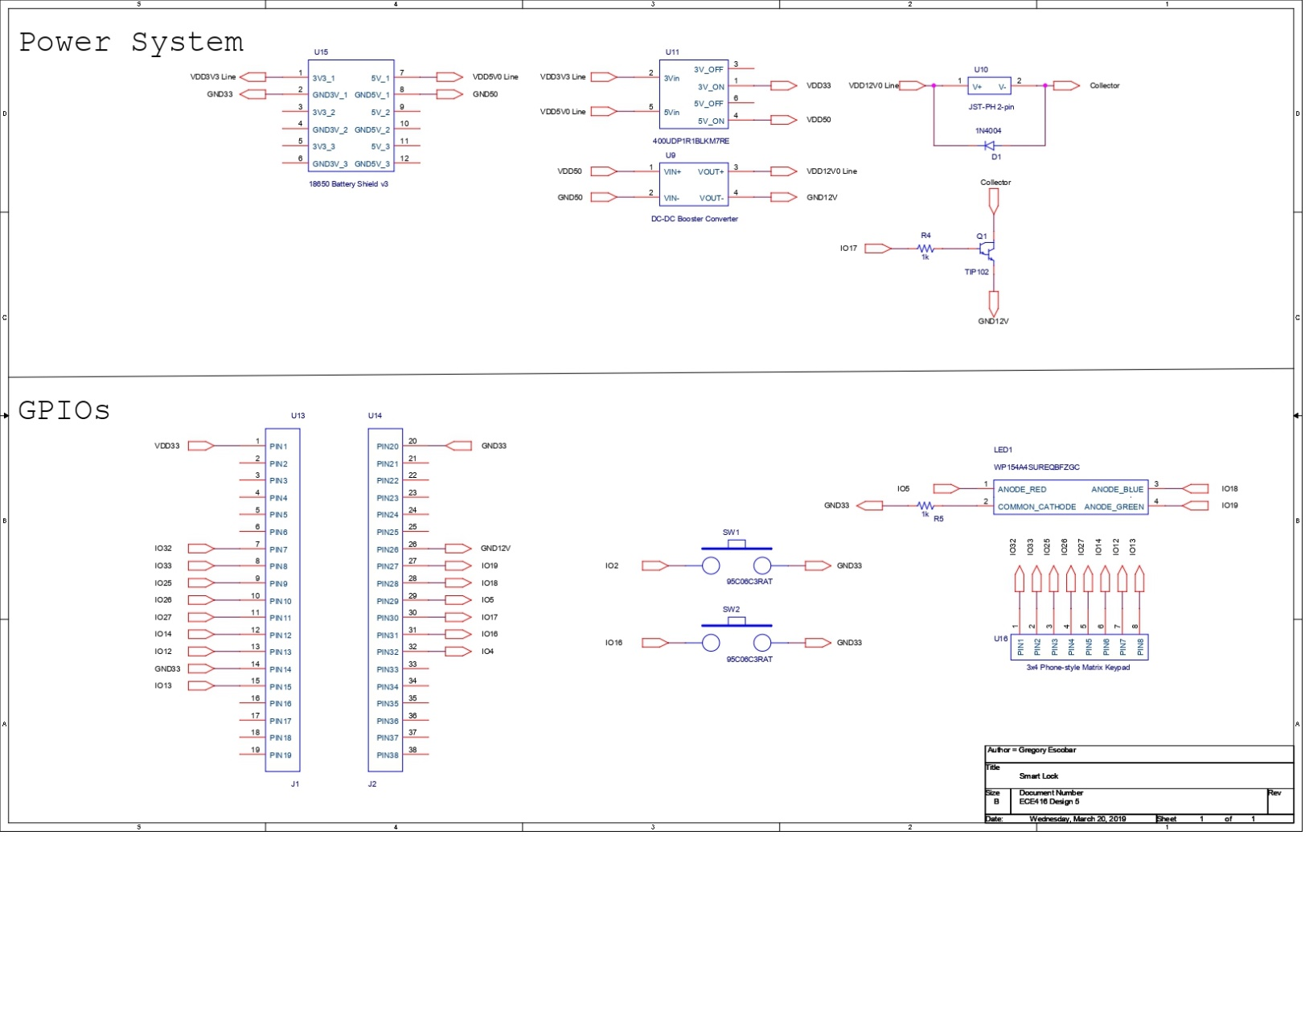

The PCB was custom designed with the help of Diego Ramos for convenience and precise connections. Components were selected and purchased on time.

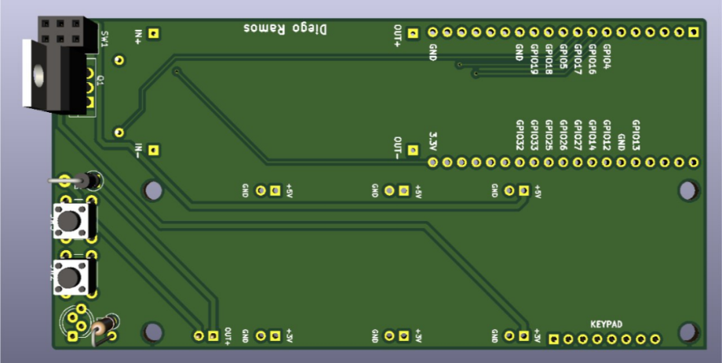

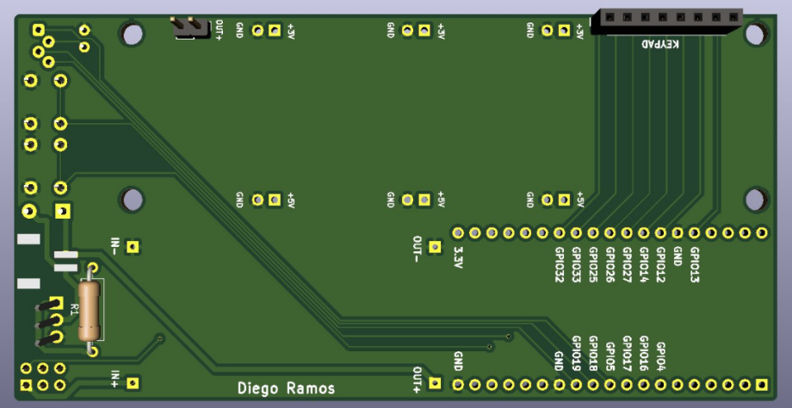

This is an updated block diagram of our project

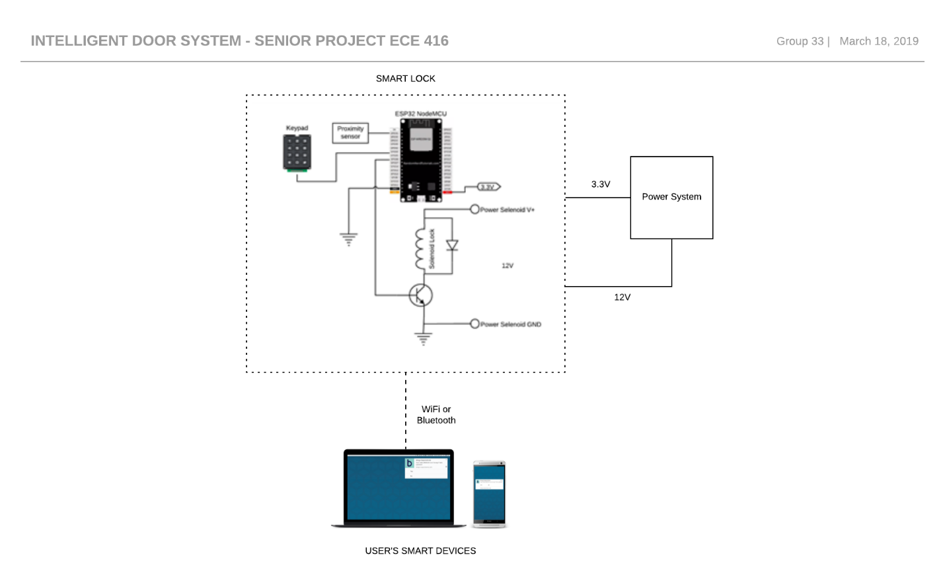

1. Milestones achieved:

* PCB design was finalized
* Components were solder and tested onto the PCB
* Keypad implementation initialized

1. Problems and roadblocks, if any:

**Hardware**

* Keypad Implantation

1. Is project on schedule? YES__X__ NO____
2. Next steps: (elaborate specifically on any problems listed in 3 and if the answer in 4. Is NO)

**Keypad Implementation:** The roadblocks we mainly encountered was with the keypad. Since the keypad was only Arduino compatible product, we had some issues with getting the keypad to work properly with the ESP32 and how to connect it to the ESP32. When we would press a 4 on the keypad the program would output a 6 and vice versa. After a further investigation as to why this was happening, we found out it had to do with the 4 and 6 being different resistances than the other keys. To fix this we had to modify our code and connect each key to different GPIOs to get the right results. After this, we are planning to add the keypad to our security system by allowing the user to select a 4 digit passcode.